- I am getting this message on screen Done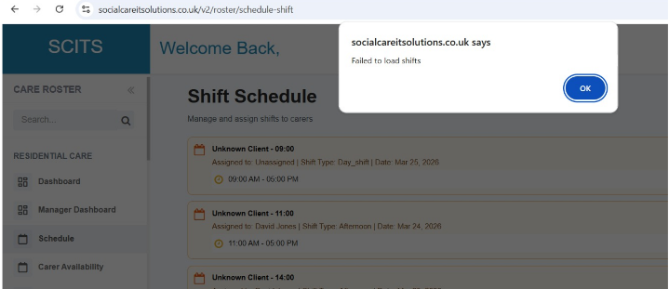
- I am able to schedule 1 person on to 2 shifts, which overlap. That shouldn't be allowed Done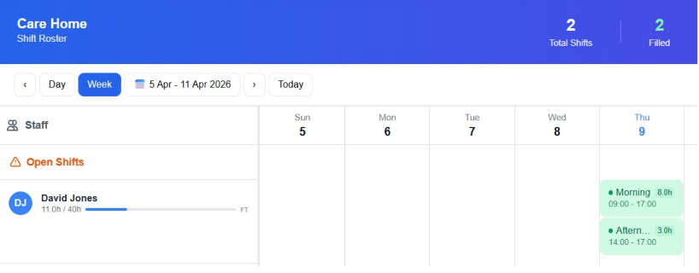
- I have created a shift and clocked in on the app, which was fine, but then 45 seconds later the app automatically clocked me out and asked me for a reason. I didn't move or click anything. Can we get this resolved, please Test this scenario in the App side
- This error has come up thus morning. I was clocked in from yesterday
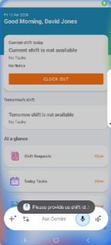
- The home area was set at 20 already I lost signal completely, I had to leave and come back in to the meeting, but no-one is there
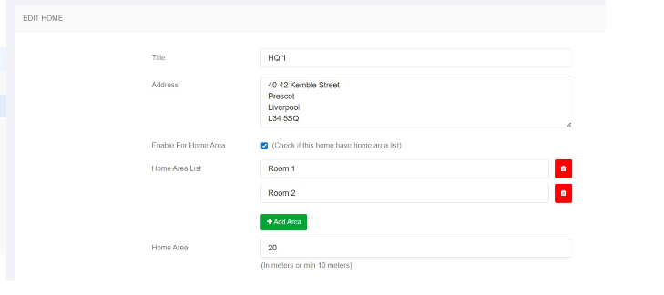
- This message came up when I tried to clock in without the QR code
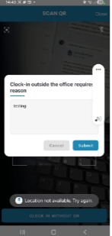
- I have set up a new home called 'new test home' and out 20m range. I have set up a new carer 'Andrew Bardsley', username: AndyB and password: Billybob72@. I have tried to 'clock in' using the QR code for the new home but it is saying you are out of range Also, David Jones is set up as the admin person for 'Omega Life' and yet when I log in to the frontend, it will only accept his log in details for HQ1, when it should for all the homes in the group. As a result, when I am trying to create a shift for Andrew Bardsley, I can only assign it to HQ1, as that is the only home offered in the drop down menu, when creating a shift
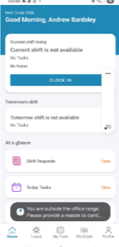
- There is no 'drop down' available for homes within the group. I can only select HQ1 No need to do the 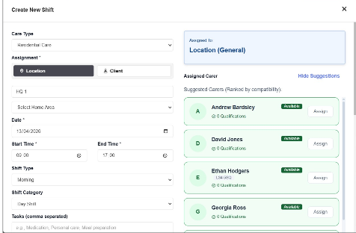
- If someone is already set up in the system, will it recognise their details? David Jones, usernale:flip, password: Podric1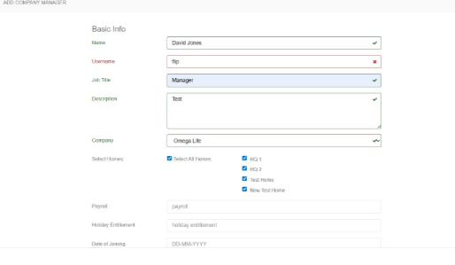
- OK but that was my point. We should be able to switch the user (if we are the super admin) to company manager Users will change roles and as such may need to have their permissions/capabilities changed rather than creating new David Jones has full permissions so I cannot understand how he cannot see (or log in to) any or all of the homes to create shifts against those homes. We need to ensure that this is possible, as companies will have area managers, split managers who look after more than 1 home, etc
- Could we please change the field which says 'contact' to mobile (if that is the information we are asking for). I have deleted Andrew Bardsley as a 'user' and created him as a 'company manager', now using the credentials, the system will not allow me to log in the front end so I can start to create shifts and a carer Done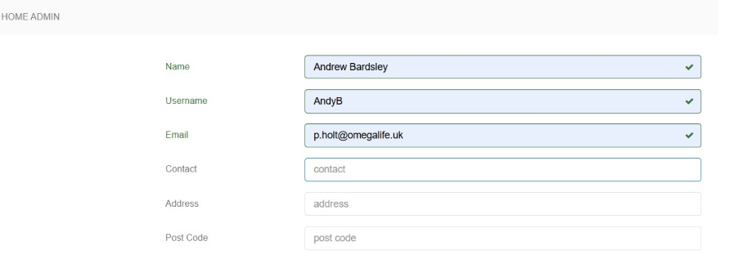
- I have just tried to clock out and a message popped up saying, wrong QR code, as per attached screenshot Test it
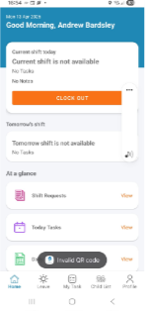
- One thing I have noticed is that when I set up the new test home yesterday. It has not copied over the 'access levels', etc. If a new home is set up under a provider, for example I have 'Omega Life' as the provider, with 4 homes within the group. I shouldn't need to go in and create all of these elements again, they should copy over, as it is the same group, or the option should be there to copy all settings Or we set them in the company and they 'feed' in to each home that is created This will greatly reduce the initial set up time for a new home within a group Done
- All of these elements should be set at 'organisation level' so they can be copied to homes that are added within the same organisation. An example being; if I have created all 'pay rates for my organisation, then when I set up a new home, these payrates should be available to be copied to the new home, rather than having to go in to the settings and set up them up again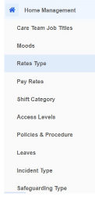
- Yes I agree. The thing is that within 1 organization these things will be set across the board, except for the odd exceptions. so we should be able to set them at 'organizational level' and then replicate in the individual home, otherwise having to set up all of these settings every time a new home is set up, is very time consuming and prone to error. If the 'super admin' sets it up and it is replicated, with the option to change any required settings, it will make set up much more coherent and simple
- I have just tried to drag and drop the shift for today on to David Jones and the attached message popped up. That is fine, but to make the flow easy and reduce clicks, we should be able to click on David's name and be taken straight to availability/schedule
This saves the user having to click numerous 'tiles' to get to the required place. We have to ensure the reduction of clicks and ease of use (UX/UI)
Can we do a 'sense' check on all areas of the system, to ensure that where we can reduce clicks, we are doing. Some will come out in th 'testing phase' but if we can consider this whilst in dev stage, it reduces changes required in the future
- Can I ask, what does the 'section' box relate to in the system (screenshots attached). 